LAB FINAL PROGRAM

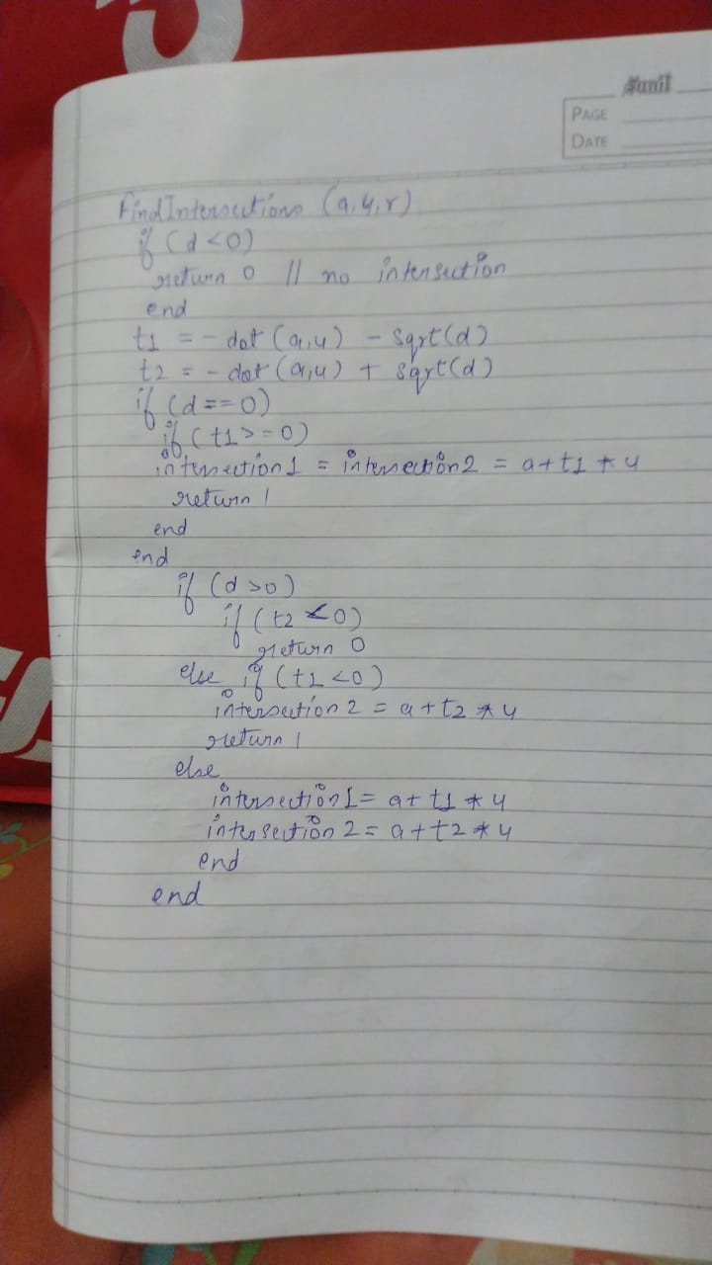

Pseudo code